합격을 축하합니다! 합격자는 본 유의사항을 숙지하여
불이익을 받는 사례가 없도록 유의하시기 바랍니다.
표준입학허가서 및 비자관련 자세한 문의 : 국제교류본부 042)821-8824
Congratulations on your successful admission to Chungnam National University.
Please make sure you fully understand the content below so as not to be at a disadvantage for your admission.
Information about Issuance of an Official Certificate of Admission can be offered by CNU Office of International Affairs : 042) 821-8824
글로벌 경쟁력을 갖춘 No.1 국립대학교
제 목
2015학년도 전기 대학원 외국인전형
합격자 유의사항
(Important Notes for Successful Applicants)

2014. 12.

For further details , please contact at this number [(042) 821-5028, 8001]

Ⅰ. Tuition Fee Payment and Abandonment of Registration
1. Payment for tuition
A. Period of tuition Payment :.20th January (Tue.) 2015 – 26th January 2015 (Mon.)
09:00-16:00 [Bank business hours]
B. Find and Print The Tuition Bill
1) Printing Period : From 19th January(Mon) 10:00– 26th January 2014. (Mon.)
2) How To Print The Bill
- Visit our website (http://www.cnu.ac.kr) you can click -> “빠른 서비스” “신입생 등록금 고지서 출력” -> Check “외국인”(International Student) -> Put your “수험번호”(Application number) and 생년월일(Birthday)
- The tuition fee will not be noticed individually.

< 1 STEP >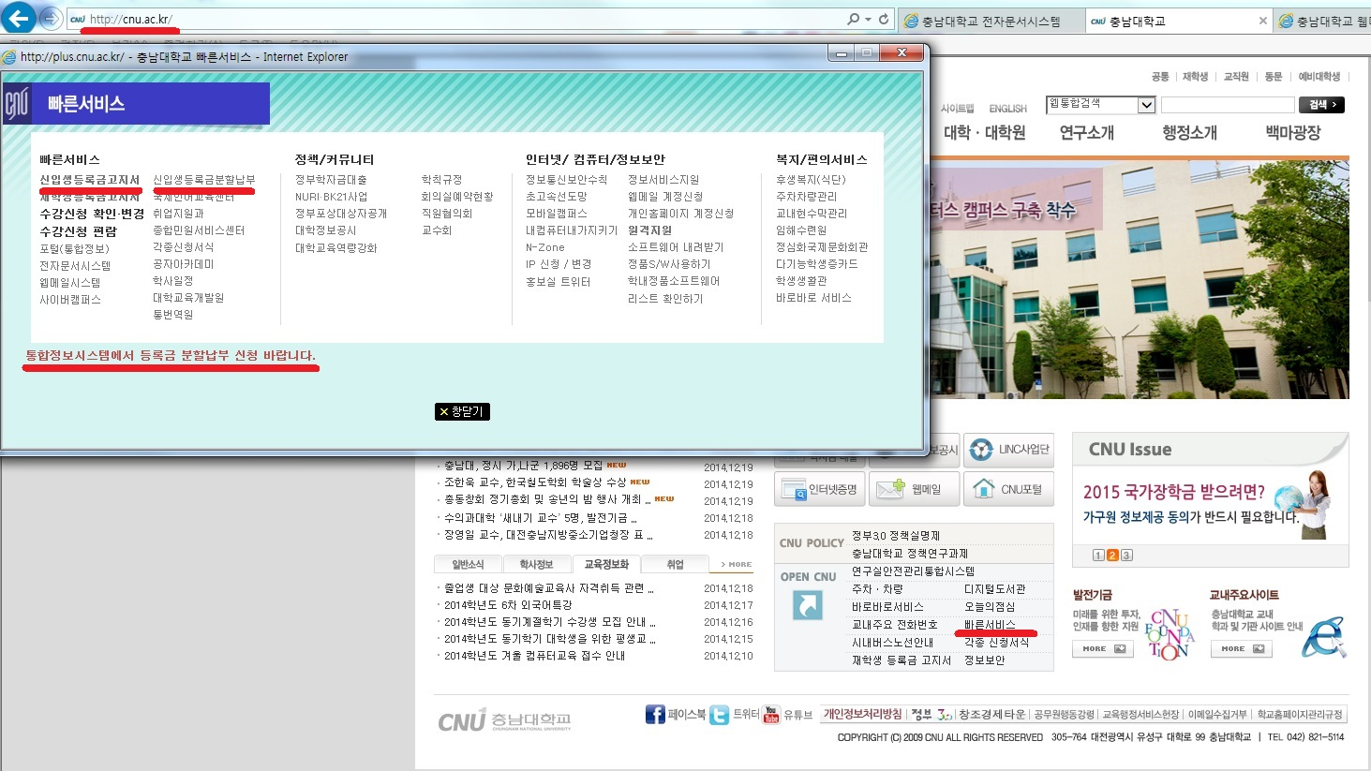
<2 STEP >
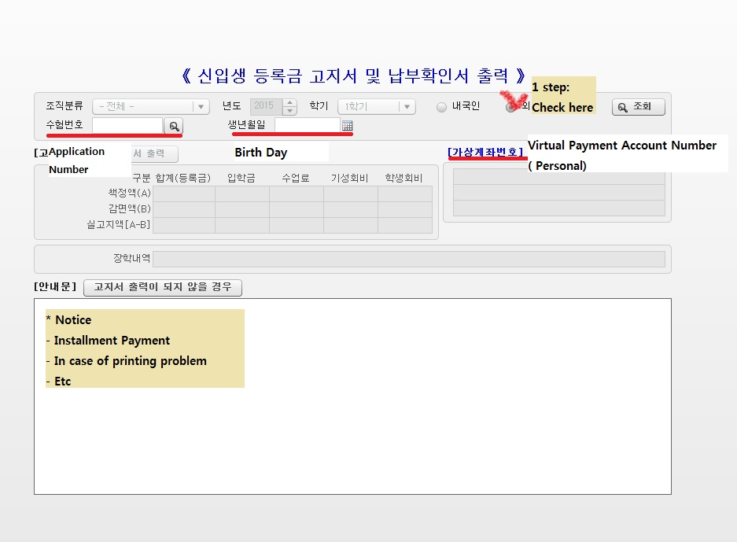
C. How to pay
1) Using Bill of Tuition Payment : Hana Bank, Woori Bank, Nong Hyup(NH), Any nationwide(Korea) locations
2) Using Virtual Payment Account : Make a deposit from ALL banks ( Deposit without a handbook, Internet banking, Phone banking, CD/ATM etc) to Personal account number on the tuition form (Bank commission is at student’s expense) – You can find your personal account number on the tuition form and bill
D. Instructions.
1) Successful applicants should submit the tuition bill at the bank even though the tuition fee will be exempted. If not, admission will be automatically rescinded.
2) If the successful applicant does not pay the tuition in the period of tuition payment , he or she will be excluded on the admission list.
3) Tuition payment should be completed by bank business hour(09:00-16:00).
4) After payment, please check whether it is completed successfully or not by following instructions.
※ After payment, applicant can confirm concerning their status of tuition payment procedure in the section “등록금고지서 출력” on the website. (http://www.cnu.ac.kr)
※ Please call at Department of financial affairs in case of trouble [☎ (042) 821-5133]

E. Installment Payment
1) Student who can not afford to pay tuition at one time
2) Period of Apply for Installment Payment : 13th January (Tue.) 2015 – 14th January 2015 (Mon.)
3) How to apply : Visit our website (http://www.cnu.ac.kr) you can click -> “빠른 서비스” “등록금분할납부신청”
4) How To Pay
- Visit our website (http://www.cnu.ac.kr) you can click -> “빠른 서비스” “신입생 등록금 고지서 출력” -> Check “외국인”(International Student) -> Put your “수험번호”(Application number) and 생년월일(Birthday)
a) Period of Installment Payment
- 1st payment : 20 January 2015 (Tue) ~ 26 January 2015 (Tue) 09:00-16:00
- 2nd payment : 23 March 2015 (Mon) ~ 24 March 2015 (Tue) 09:00-16:00
b) NOTICE
- 2nd payment period will be changed.
- Students who doesn’t pay at the right time will be expelled from school.
c) The amount of tuition
- 1st payment : Entrance fee + Course Fee
- 2nd payment : School Supporting Fee
d) Instructions.
1) Successful applicants should submit the tuition bill at the bank even though the tuition fee will be exempted. If not, admission will be automatically rescinded.
2) If the successful applicant does not pay the tuition in the period of tuition payment , he or she will be excluded on the admission list.
3) Tuition payment should be completed by bank business hour(09:00-16:00).
4) After payment, please check whether it is completed successfully or not by following instructions.
※ After payment, applicant can confirm concerning their status of tuition payment procedure in the section “등록금고지서 출력” on the website. (http://www.cnu.ac.kr)
※ Please call at Department of financial affairs in case of trouble [☎ (042) 821-5133]

E. Gradudation Program Tuition for 2015 Spring Semester
단 과 대 학 | 모 집 단 위 | 등 록 금 액
 |  | 입학금 | 수업료 | 기성회비 | 합 계
인문․사회과학대학 | 전 모집단위 | 181,000 | 377,500 | 1,291,500 | 1,850,000
자연과학대학 | 수학과 | 181,000 | 387,000 | 1,480,500 | 2,048,500
 | 무용학과 | 181,000 | 387,000 | 1,976,000 | 2,544,000
 | 기타 모집단위 | 181,000 | 387,000 | 1,672,000 | 2,240,000
경상대학 | 전 모집단위 | 181,000 | 377,500 | 1,280,000 | 1,838,500
공과대학 | 전 모집단위 | 181,000 | 414,000 | 2,008,000 | 2,603,000
농업생명과학대학 | 농업경제학과 | 181,000 | 377,500 | 1,291,500 | 1,850,000
 | 기타 모집단위 | 181,000 | 387,000 | 1,656,500 | 2,224,500
생활과학대학 | 전 모집단위 | 181,000 | 387,000 | 1,656,500 | 2,224,500
생명시스템과학대학 | 전 모집단위 | 181,000 | 387,000 | 1,656,500 | 2,224,500
- Entrance fee is only for the first semester.
- Tuition can be changed, above table is based on 2014 fall semester.

2. Notice that you need to be aware of (http://ipsi.cnu.ac.kr)

A. Applicant, who wants to renounce the registration, should submit a registration waiver form or a Bill for tuition refund after all procedures of registration.

B. Chungnam National University will give the tuition back to the renouncer only if some refundable reasons happen to them in accordance with the second clause of Article 6「 the rules of University Tuition」

Issue Date for refundable reasons | Repayment of tuition | Note
Before the entrance | All tuition fees
Before 30days from the entrance | 5/6 of Tuition fees( Excluded entrance fees)
After the entrance from 30days to 60days before | 2/3 of Tuition fees( Excluded entrance fees)
After the entrance from 60days to 90days before | 1/2 of Tuition fees( Excluded entrance fees)
After 90 days from the entrance | Not refundable

Ⅱ. Additional documents to be submitted
1. Diploma/Graduation(Degree)Certificate (1 copy)
A. Verification Documents
All successful applicants must submit the verification documents.
B. Required documents (Choose one)
- Apostille Certificates
- Certificate of your educational back ground certified by the Korean embassy/consul in your country or your country’s consul/embassy in Korea.
+ NOTICE: Apostille is compulsary for Mongolia and Japan in ASIA (other Apostille member county).
: You need to get Apostille seal on your graduation certificate/Dipoma. For the department to take care of the Apostille is different in each nations, you have to find out it(usually ‘Ministry of Foreign Affairs and Trade’ takes care of it)

C. The Office for submission and the date: The Admission Office (E7-1), End of December 2014

2. Request for Student card (Smart card)
A. Period: From 2nd March 2015 (Mon.)

B. Location : The first student hall(제 1학생회관), Hana Bank(Building W-8)

C. Please bring your photo (a 3x4 photo) 1 unit, Identification card (Passport or Alien Card in Korea)

D. HOW TO REQUEST
○ When the student visit HanaBank with the supplies prepared, he or she can individually fill out the application form(Receipts right away)

Ⅲ. Orientation and Registration for courses
1. Entrance Ceremony
- Period : 27th February.2015(FRI.) 14:00
- Location : JeongSimHwa International Cultural Center(E1-2)
- Should come 30 min earlier and take a seat(13:30)
2. Orientation
-Period : 27th February.2015(FRI.) 15:00
-Location: International Affairs Office(E1-1,101호)
3. Registration for courses
- Period :
Freshmen : 9th February 09:30~– 11th February
Transferred Students : 2nd March ~ 6th March
A. How to register : Through the website (http://cnuis.cnu.ac.kr/)
- Students must pay tuition fee before registering course.
- Log on with your registration number(ID) and password.
- Initial password is 100000 for male student and 2000000 for female student
- Initial password is last 7 digit of your alien card number ( Student who has an alien card)
- Transferred students must check his/her credits which is acceptable to be transferred
Discuss with your department
- You can change your password once you log on the page.

B . Instructions

(a). Successful applicants should take a course in the scheduled period for registration after discussion with Individual department.
(b) To correct your personal information on the CNU system, contact [학사지원과 (042) 821-5032~3]
or Individual department.

Ⅳ. Dormitory Guide
1. Scheduled Date for Move in: 2015. 2. 27th.(FRI.) ~ 3. 1st.(Sun.) 09:00 - 15:00
※ Please comply with this scheduled date and check the notice on dormitory homepage concerning details for dormitory .(http://dorm.cnu.ac.kr/ 821-6181 / dormitory@cnu.ac.kr
▶ After March 2nd, 2015, the student can move in (Only within business hours 09:00~17:00, the weekend is not admitted)

2. Period of Use : The first semester 2015 (During Spring Semester)-
A. Period for application : during the application for admission
B. How to apply : the application form
C. Vacation residence, Extending residence : need to apply in proper time.
(※There is no additional application for the student who didn’t check on the application form.)

C. Announcement for Residence list : 2014.1. 19.(Mon.) 14:00 (Scheduled)
※ After the personal authentification through the dormitory web site, students individually confirm or SMS message will be sent.

3. Payment for Dormitory Fees
A. Dormitory fees : (Check the table below)
※ It could be arranged against students’ own intention because of shortage in the case of room for the married.
B. Payment
1) Period: 2015. 1.21.(Wed) ~ 1. 22.(Thu.) 09:00~16:00 (Bank Business hours)
2) Payment Bill: Dormitory Web Site (On site payment or transfer the money into virtual account ) or Using Credit Card(Hana, Woori, Shinhan, KB) (http://dorm.cnu.ac.kr)
3) Location : (On Site Payment)Hana Bank
4) Who wants to renounce the registration dormitory, should submit a registration waiver form until 26th FEB. 2015 (THU), then can refund the dormitory fee.

5. The Notices about Dormitory
A. If the student does not pay the dormitory fees, he or she could be considered as a renouncer (resident)
Division type |  | Dormitory fees(15 weeks) (WON) |  |  | Note
 |  | Maintenance | Food expenses | Total
2people/1room | Apartment(1,5,6building) | 476,150 | 428,400~549,180 | 904,550  ~1,025,330 | Included Food  (excluded lunch on weekdays)
 | Hallway(2,3,7,8,9,11) | 508,250 | 428,400~549,180 | 936,650  ~1,057,430
Baekhaengsa  (medicine/ 2people) |  | 1,066,790 | - | 1,066,790 | Excluded Food expenses
2people/1room  Married person(10building) |  | 448,330 | - | 448,330

B. Guide for menu
 | Weekdays  (Breakfast/Dinner) | Weekend  (times) | Food expenses(won) | Note
Type 1 | 10times | 0 | 428,400원 | 3,000(won) for separate payment
Type 2 |  | 2 | 475,800원
Type 3 |  | 4 | 511,200원
Type 4 |  | 6 | 549,180원

C. For further details, please call at Dormitory Office [ ☎ (042) 821 - 6181 ~ 6183 ]

Guide for utilizing personal information

We informed that personal information on the application form will be utilized only for student’s academic affairs concerning the student beginning of March 1,2015

Department Office

College | Department | Office Phone | Building Name / Location
Humanities | 국어국문학과 | 821-5321 | 인문대학 W7 429호
 | 영어영문학과 | 821-5331 | 인문대학 W7 446호
 | 독어독문학과 | 821-5341 | 인문대학 W7 356호
 | 불어불문학과 | 821-5351 | 인문대학 W7 442호
 | 중어중문학과 | 821-5361 | 인문대학 W7 312호
 | 일어일문학과 | 821-5371 | 인문대학 W7 445호
 | 한문학과 | 821-5381 | 인문대학 W7 201호
 | 사학과 | 821-5391 | 인문대학 W7 320호
 | 국사학과 | 821-6311 | 인문대학 W7 318호
 | 철학과 | 821-6321 | 인문대학 W7 410호
 | 고고학과 | 821-6381 | 인문대학 W7 404호
 | 언어학과 | 821-6391 | 인문대학 W7 203호
Social Sciences | 사회학과 | 821-6331 | 사회과학대학 W12-1 323호
 | 문헌정보학과 | 821-6351 | 사회과학대학 W12-1 428호
 | 심리학과 | 821-6361 | 사회과학대학 W12-1 429-2호
 | 언론정보학과 | 821-6371 | 사회과학대학 W12-1 425호
 | 행정학과 | 821-5841 | 사회과학대학 W12-1 224호
 | 정치외교학과 | 821-5851 | 사회과학대학 W12-1 227호
 | 자치행정학과 | 821-5861 | 사회과학대학 W12-1 327호
 | 사회복지학과 | 821-6471 | 사회과학대학 W12-1 326호
Natural Sciences | 수학과 | 821-5421 | 자연대 이학1호관 W5 1215호
 | 정보통계학과 | 821-5431 | 자연대 이학2호관 W4 2324호
 | 물리학과 | 821-5451 | 자연대 기초2호관 W11-2 2233호
 | 천문우주과학과 | 821-5461 | 자연대 기초2호관 W11-2 2318호
 | 화학과 | 821-5471 | 자연대 기초2호관 W11-2 2103호
 | 생화학과 | 821-5481 | 자연대 기초1호관 W11-1 1111호
 | 지질환경과학과 | 821-6421 | 자연대 기초1호관 W11-1 1123호
 | 해양환경과학과 | 821-6431 | 자연대 기초1호관 W11-1 1521호
 | 무용학과 | 821-6481 | 자연대 이학1호관 W5 1302호
 | 스포츠과학과 | 821-6451 | 자연대 이학1호관 W5 1322호
Economics & Management | 경제학과 | 821-5521 | 경상대학 E6 241호
 | 경영학부 | 821-5531 | 경상대학 E6 232호
 | 무역학과 | 821-5551 | 경상대학 E6 229호

College | Department | Office Phone | Building Name/Location
Engineering | 건축학과 | 821-5621 | 공과대학 2호관 E2 2214호
 | 건축공학과 | 821-5621 | 공과대학 2호관 E2 2214호
 | 토목공학과 | 821-5671 | 공과대학 2호관 E2 2216호
 | 환경공학과 | 821-6671 | 공과대학 3호관 E3 3324호
 | 기계공학과 | 821-5641 | 공과대학 4호관 E4 4311호
 | 기계설계공학과 | 821-6641 | 공과대학 4호관 E4 4416호
 | 메카트로닉스공학과 | 821-6871 | 공과대학 4호관 E4 4517호
 | 선박해양공학과 | 821-6621 | 공과대학 3호관 E3 3101호
 | 항공우주공학과 | 821-6681 | 공과대학 3호관 E3 3318호
 | 나노소재공학과 | 821-5631 | 공과대학 1호관 W3 1358호
 | 재료공학과 | 821-6631 | 공과대학 1호관 W3 1302호
 | 고분자공학과 | 821-6661 | 공과대학 1호관 W3 1473호
 | 유기소재․ 섬유시스템공학과 | 821-6611 | 공과대학 1호관 W3 1223호
 | 정밀응용화학과 | 821-6691 | 공과대학 1호관 W3 1145호
 | 화학공학과 | 821-5681 | 공과대학 1호관 W3 1250호
 | 전기공학과 | 821-5651 | 공과대학 2호관 E2 2167호
 | 전자공학과 | 821-5889 | 공과대학 2호관 E2 2403호
 | 전파공학과 | 821-6881 | 공과대학 2호관 E2 2413호
 | 정보통신공학과 | 821-6861 | 공과대학 3호관 E3 3415호
 | 컴퓨터공학과 | 821-5441 | 공과대학 1호관 W3 1414호
Agriculture and Life Science | 응용식물학과 | 821-5721 | 농생대 1호관 E10-1 1214호
 | 원예학과 | 821-5731 | 농생대 1호관 E10-1 1316호
 | 산림환경자원학과 | 821-5741 | 농생대 1호관 E10-1 1113호
 | 응용생물학과 | 821-5761 | 농생대 1호관 E10-1 1412호
 | 동물자원생명과학과 | 821-5771 | 농생대 2호관 E10-2 2307호
 | 동물바이오시스템과학과 | 821-5781 | 농생대 2호관 E10-2 2408호
 | 지역환경토목학과 | 821-5791 | 농생대 3호관 E10-2 3102호
 | 바이오시스템기계공학과 | 821-6711 | 농생대 2호관 E10-2 1207호
 | 환경소재공학과 | 821-5751 | 농생대 3호관 E10-2 3419호
 | 식품공학과 | 821-6721 | 농생대 2호관 E10-2 3202호
 | 생물환경화학과 | 821-6731 | 농생대 2호관 E10-2 2422호
 | 농업경제학과 | 821-6741 | 농생대 1호관 E10-1 1302호
Human Ecology | 의류학과 | 821-6821 | 생활과학대학 N14 104호
 | 식품영양학과 | 821-6831 | 생활과학대학 N14 421호
 | 소비자생활정보학과 | 821-6841 | 생활과학대학 N14 402호
Veterinary Medicine | 수의학과 | 821-6751 | 수의과대학 N13-1 202호
Nursing | 간호학과 | 580-8321 | 간호대학 401호[문화동]
Bioscience | 생물과학과 | 821-5491 | 생명시스템과학대학 N11 111호
 | 미생물분자생명과학과 | 821-6411 | 생명시스템과학대학 N11 111호
<Other Office>
담 당 업 무 | 안 내 부 서 | 전 화 번 호  (지역번호 : 042) | 비 고
입 학 관 리 | 입학과 | 821-5028, 8001 | 입학관리본부 N2 1층
지도교수, 논문,  졸업자격시험,  수강신청, 학점인정, | 대학원행정실 | 821-5046, 7053, 7054 | 대학본부 E7 309호
장학금(학자금대출) | 학생과 | 821-5084, 5049 | 대학본부 E7 111호
학생증 발급 및 신청 | 학생과 | 821-5049,  544-1111 | 대학본부 E7 111호  1학생회관 하나은행
병사 및 예비군 신고 | 예비군연대 | 821-6121 | 자연대 2호관 W4  2113호
등록금 납부․확인 | 재무과 | 821-5133 | 대학본부 E7 102호
취업 | 취업지원과 | 821-5248, 6154 | 제2후생관 E5 2층
외국인 유학생 관리 | 국제교류본부 | 821-8822 | 국제교류관 E1-1 209호
언어교육 | 국제언어교육센터 | 821-8805 | 국제교류관 E1-1 212호
단과대학 행정실 | 인 문 대 학 | 821-5312, 5313, 5314
 | 사회과학대학 | 821-6212, 6213, 6214
 | 자연과학대학 | 821-5412, 5413, 5414
 | 경 상 대 학 | 821-5512, 5513, 5514
 | 공 과 대 학 | 821-5612, 5613, 5617
 | 농업생명과학대학 | 821-5712, 5713, 5714
 | 법학전문대학원 | 821-5812, 5813, 5814
 | 약 학 대 학 | 821-5912, 5914
 | 의학전문대학원 | 580-8112, 8113, 8116 | 보운캠퍼스
 | 생활과학대학 | 821-6812, 6814
 | 예 술 대 학 | 821-6912, 6914
 | 수의과대학 | 821-6775, 6776
 | 사 범 대 학 | 821-8563
 | 간 호 대 학 | 580-8301 | 보운캠퍼스
 | 생명시스템과학대학 | 821-5572, 5491, 6411

